**Networking**

Class IX

**Lecture 22**

**Network Model & TCP/IP Model**

**.**

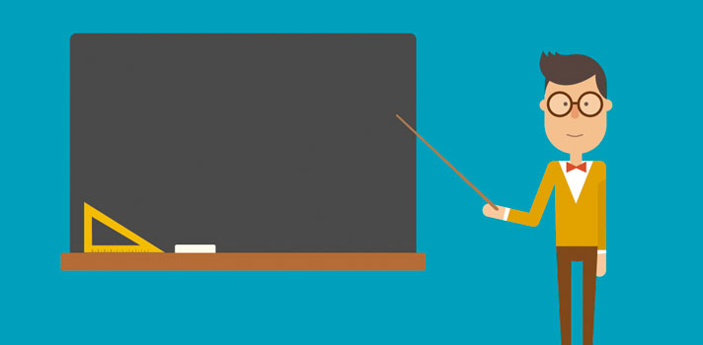

**Lab Objectives:**

* Network Models.
* The 7 layers of OSI model.
* TCP/IP model.

**Network Models**

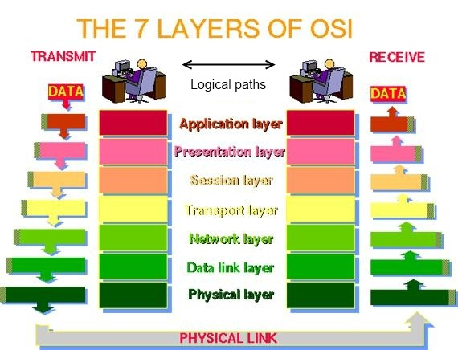

***To simplify networks, everything is separated in layers and each layer handles specific tasks and is independent of all other layers. Control is passed from one layer to the next, starting at the top layer in one station, and proceeding to the bottom layer, over the channel to the next station and back up the hierarchy. Network models are used to define a set of network layers and how they interact. The two most widely recognized network models include the TCP/IP Model and the OSI Network Model.***

**The 7 layers of osi model**

***The Open System Interconnect (OSI) is an open standard for all communication systems. The OSI model defines a networking framework to implement protocols in seven layers.***

**Physical Layer**

***This layer conveys the bit stream - electrical impulse, light or radio signal -- through the network at the electrical and mechanical level. It provides the hardware means of sending and receiving data on a carrier, including defining cables, cards and physical aspects. Examples include Ethernet, FDDI, B8ZS, V.35, V.24, and RJ45.***

**Data Link Layer**

***At this layer, data packets are encoded and decoded into bits. It furnishes transmission protocol knowledge and management and handles errors in the physical layer, flow control and frame synchronization. The data link layer is divided into two sub layers: The Media Access Control (MAC) layer and the Logical Link Control (LLC) layer. Examples include PPP, FDDI, ATM, and IEEE 802.5 / 802.2, IEEE 802.3/802.2, HDLC, and Frame Relay.***

**Network Layer**

***This layer provides switching and routing technologies, creating logical paths, known as virtual circuits, for transmitting data from node to node. Routing and forwarding are functions of this layer, as well as addressing, internetworking, error handling, congestion control and packet sequencing. Examples include AppleTalk DDP, IP, and IPX.***

**Transport Layer**

***This layer provides transparent transfer of data between end systems, or hosts, and is responsible for end-to-end error recovery and flow control. It ensures complete data transfer. Examples include SPX, TCP, and UDP.***

**Session Layer**

***This layer establishes, manages and terminates connections between applications. The session layer sets up, coordinates, and terminates conversations, exchanges, and dialogues between the applications at each end. Examples include NFS, NetBIOS names, RPC, SQL.***

**Presentation Layer**

***This layer provides independence from differences in data representation (e.g., encryption) by translating from application to network format, and vice versa. This layer formats and encrypts data to be sent across a network, providing freedom from compatibility problems. Examples include encryption, ASCII, EBCDIC, TIFF, GIF, PICT, JPEG, MPEG, and MIDI.***

### Application Layer

***This layer supports application and end-user processes. Communication partners are identified, quality of service is identified, user authentication and privacy are considered, and any constraints on data syntax are identified. Everything at this layer is application-specific. This layer provides application services for file transfers, e-mail, and other network software services. Examples include WWW browsers, NFS, SNMP, Telnet, HTTP, and FTP.***

***7 layers of OSI model:***

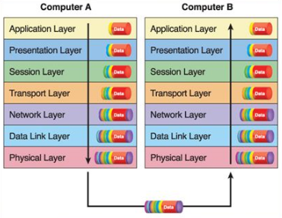

***Fig: OSI Model***

## The TCP/Ip model

***The TCP/IP network model is a four-layer reference model. All protocols that belong to the TCP/IP protocol suite are located in the top three layers of this model.***

### Application

***Defines TCP/IP application protocols and how host programs interface with transport layer services to use the network. Protocol examples include HTTP, Telnet, FTP, TFTP, SNMP, DNS, and SMTP.***

### Transport

***Provides communication session management between host computers. Defines the level of service and status of the connection used when transporting data. Protocol examples include TCP, UDP, and RTP.***

### Internet

***Packages data into IP datagram’s, which contain source and destination address information that is used to forward the datagram’s between hosts and across networks. Performs routing of IP datagram’s. Protocol examples include IP, ICMP, ARP, and RARP.***

### Network interface

***Specifies details of how data is physically sent through the network, including how bits are electrically signaled by hardware devices that interface directly with a network medium, such as coaxial cable, optical fiber, or twisted-pair copper wire. Protocol examples include Ethernet, Token Ring, FDDI, X.25, Frame Relay, RS-232, v.35.***

***TCP/IP Model:***

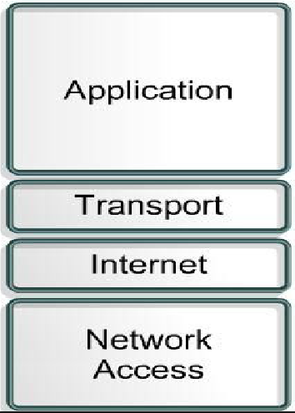

***Fig: TCP/IP model.***



***Thank you***